Department of Computer Science and Engineering
The University of Texas at Arlington

Team: Survivors
Project: Sight By Touch
Team Members:
Gerardo Guevara
Kevin Tran
Victor Rodriguez
Margaret Floeter
Henry Loh

Last Updated: 11/30/2013

Table of Contents
Table of Contents 2
Document Revision History 5
List of Figures 6
List of Tables 7
1. Introduction 8
1.1 Purpose and Use 8
1.2 Product Concept 8
1.3 Product Scope 9
1.4 Key Requirements 10
2. Meta Architecture 12
2.1 Architectural Vision 12
2.2 Guiding Principles 12
2.2.1 Adaptability 12
2.2.2 Maintainability 12
2.2.3 Modularity 12
2.2.4 Portability 13
2.2.5 Real-time Performance 13
2.2.6 Reliability 13
2.2.7 Usability 13
2.3 Assumptions 13
3. Layer Definitions 14
3.1 Data Driver Layer 15
3.2 Warning Layer 15
3.3 Notification Layer 15
4. Layer Description 16
4.1 Data Acquisition Layer 16
4.1.2 Assumptions 16
4.1.3 Responsibilities 17
4.1.4 Subsystems 17
4.2 Event Manager Layer 20
4.2.2 Assumptions 20
4.2.3 Responsibilities 20
4.2.4 Subsystems 20
4.3 Processing Layer 25
4.3.2 Assumptions 25
4.3.3 Responsibilities 25
4.3.4 Subsystems 25
4.4 Notification Layer 29
4.4.2 Assumptions 29
4.4.3 Responsibilities 29
4.4.4 Subsystems 29
5. Inter-Subsystem Data Flow 33
Inter-Subsystem Data Flow Section 33
6. Operating System Dependencies 36
6.1 Data Acquisition Layer 36
6.2 Event Manager Layer 36
6.3 Processing Layer 36
6.4 Notification Layer 36
7. Testing Considerations 37
7.1 Overall Considerations 37
7.1.1 Durability 37
7.1.2 User 37
7.2 Layer-level Considerations 37
7.2.1 Data Acquisition Layer 37
7.2.2 Event Manager Layer 38
7.2.3 Processing Layer 38
7.2.4 Notification Layer 38

Document Revision History
Revision Number | Revision Date | Description | Rationale
1.0 | 11/30/2013 | First ADS Draft | Team’s Initial Draft

List of Figures
Figure # Title Page #
3-1 Architecture Layers Diagram #
4-1 Data Acquisition Layer #
4-2 Event Manager Layer #
4-3 Processing Layer #
4-4 Notification Layer #
5-1 Architectural Data flow Diagram #

List of Tables
Figure # Title Page #
1-1 Key Architectural Design Requirements #
4-1 User Input Inter-layer Interfaces #
4-2 User Input Public Interfaces #
4-3 Distance Sensor Input Inter-layer Interfaces #
4-4 Distance Sensor Input Public Interfaces #
4-5 Battery Sensor Input Inter-layer Interfaces #
4-6 Battery Sensor Input Public Interfaces #
4-7 User Event Manager Inter-layer Interfaces #
4-8 Detection Event Manager Inter-layer Interfaces #
4-9 Low Battery Event Inter-layer Interfaces #
4-10 On/Off Inter-layer Interfaces #
4-11 Logical Inter-layer Interfaces #
4-12 On/Off Notification Inter-layer Interfaces #
4-13 On/Off Notification Public Interfaces #
4-14 Object Notification Inter-layer Interfaces #
4-15 Object Notification Public Interfaces #
4-16 Battery Notification Inter-layer Interfaces #
4-17 Battery Notification Public Interfaces #
5-1 Sample Inter-Subsystem Data Element Descriptions #
5-2 Producer-Consumer Relationships #

1. Introduction

Purpose and Use
The purpose of the Sight By Touch System is to aid visually impaired individuals since they are unable to rely on their sight. More often than not, visually impaired individuals require some form of aid to help guide them, usually through the use of a cane or a service animal. Our team wishes to remove, or decrease, this dependency by allowing the user to be guided through vibrations from the system. In this way, the user’s hands will be free from having to hold a cane or a leash. With this system, a user shall be able to avoid collision with any obstacles that are found in their environment. Our team has decided to make the system an indoor and outdoor system. The system shall lead the user in a safe direction by warning them when an object is within the detection range of the sensors. The system does this through vibrations from its vibration motors. When the sensors sense an object, the vibration motor closest to that object will vibrate. This system is used solely for the purpose of helping visually impaired users navigate in unknown environments. This product is not intended to be used in a crowded area because there would be too much interference from the surrounding objects.

Product Concept
The Sight By Touch system shall consist of an external belt that holds the main battery, which connects to the sensors and vibration motors. When the user is not using the product and wishes to charge the batteries, the batteries will be removed from the system and put into a docking station to charge.
The system will be a full-blown suit with the sensors underneath the clothes and with their wires connected to the microcontroller. The sensors will be detachable to allow for flexibility and cleanliness. The system will focus on the front of the user (180 degrees, at least a 3 feet radius horizontally, and from the neck to the ankles vertically).
There will be multiple vibration motors distributed along the system, embedded in the suit. When the sensor connected to those vibration motors senses an object within the range, the sensor will send a signal to the microcontroller, which will then forward the message to the vibration motor. There can be multiple vibration motors vibrating at the same time and at different intensities depending on where the object is located. The closer the object is the more intense the vibration will be. In addition, depending on the location of the object being detected, the vibration motors closest to that object will vibrate the most.
The belt will allow the user to interface with the device. The interface will have an on/off button to turn the sensors on/off. In addition, there will be a knob that allows the user to adjust the range that the sensors will detect. There will be no external elements for all the functions and data manipulation will be done internally.

Product Scope
The Sight By Touch system is made to aid visually impaired users through the use of vibrations. Users of the Sight By Touch system will be able to move around and gauge where they are. When a user walks near an object, the system will vibrate in the direction where the object is closest. This warns the user that there is an object nearby and thus prevents the user from colliding with the object. With the use of these vibrations created by the system, a visually impaired user will be able to avoid obstacles. The system will not be able to detect the absence of flooring such as a hole or a staircase.
The intended audiences for the Sight By Touch system are individuals who are visually impaired. We consider the visually impaired to be based on the following metrics provided by the American Optometric Association:
- 20/70 to 20/160 is considered moderate visual impairment, or moderate low vision
- 20/200 to 20/400 is considered severe visual impairment, or severe low vision
- 20/500 to 20/1,000 is considered profound visual impairment, or profound low vision
- less than 20/1,000 is considered near-total visual impairment, or near total blindness
- no light perception is considered total visual impairment, or total blindness

Key Requirements
The follow table, 1-1, contains the key requirements for the Sight by Touch System. These requirements are the main requirements that will determine the architectural design of the system. The full list of requirements can be found in the System Requirements Specification document.
Number | Requirement | Description
3.1 | On and Off | The system shall be able to be turned on/off by the click of a button followed by some notification that the system was powered on or off. The preferred method of notification is through vibrations.
3.2 | Detect Obstructions | The system shall be able to detect the presence of nearby objects that are in front and/or to the sides of the user that can impede the user from moving forward. The detection area of the system will need to cover at least a 3 foot radius in front of the user including the sides and vertically from the neck to the ankles.
3.3 | Obstruction Notification | The system shall be able to warn the user of the presence of nearby objects through the use of vibrations. The intensity of the vibrations felt by the user will correspond to the direction and the distance of the object(s) that the system has detected.
3.4 | Battery Powered | The system shall be powered by a rechargeable battery.
3.5 | Inconspicuous Appearance | The system shall be as discrete as possible in order to attract the least amount of attention.
3.6 | Low Battery Notification | The system shall be able to notify the user when the battery has less than an hour left of charge and again when the battery has less than thirty minutes left of charge.
3.7 | User Friendly | The system shall be user friendly so that anyone with or without sight can operate it. The functions will be intuitive and easy to learn.
5.2 | Real-Time Response | The system shall be able to detect objects and notify the user through vibrations between 30 milliseconds to 100 milliseconds.
5.3 | Detection Quality | The system shall be able to detect objects within 10 feet max.
5.4 | Vibration Intensity | The system shall have a safe vibration intensity of 0.063 m/s2 to 1.15 m/s2. This range ensures that the system can warn the user without harming the user.
5.5 | Battery Life | The rechargeable battery shall last between 6-10 hours on full recharge cycles.
6.4 | Heat Dissipation | The system shall dissipate heat produced by the components of the system to prevent overheating.
6.6 | Skin Irritation | The system shall not irritate the skin of the user. Vibrations should be kept at a safe range to avoid harming the skin of the user.
8.1 | Weight | The entire system shall be weight under six pounds.
8.3 | Adjustable Range | The system shall be able to allow the user to select from the predefined max range radius of 3 or 10 feet.
Table 1-1: Key Architectural Design Requirements

2. Meta Architecture
The Meta Architecture section describes the architectural vision, Guiding Principles, and Assumptions that will affect how we will design the Sight by Touch System. The architectural vision is an overview of the system layers and gives a brief explanation of the overall functionality of the system. Our team came up with guiding principles to help guide us when making architecture design decisions. We list each principle and the reason as to why the team feels it is important. Key assumptions that the architectural design is based on are also listed in this section. Finally, we list tradeoffs that were made during the initial design of the architecture.

2.1 Architectural Vision
In order to have the most efficient data flow, our architectural structure has been broken up into four layers. The layers include the Data Acquisition layer, the Event Manager layer, the Processing layer, and the Notification layer.

2.2 Guiding Principles

2.2.1 Adaptability
The user will be able to adapt to the Sight By Touch system’s user interface and the vibrations’ position and intensity to navigate in real world environments. This will affect the number of distinct vibration patterns the system will use along with the flow of the data.

2.2.2 Maintainability
The Sight By Touch system shall be designed and built in a way such that the finished product will have replaceable components. The purpose of this guideline is to allow for the replacement of components that are defective so that the distributor does not have to replace the entire system. This will affect what type of data and the way that data is passed between subsystems.

2.2.3 Modularity
The Sight By Touch system shall be designed so that the software interface and the hardware components are self-contained units and not specifically dependent on each other. Any changes to the software interface and/or hardware components will not affect the other unit.

2.2.4 Portability
The Sight By Touch system shall assist the user to navigate wherever they need to go. So, the system must be compact, lightweight, and especially portable so that the user may be able wear and utilize it. This will limit the number of layers that we have.

2.2.5 Real-time Performance
The Sight By Touch system shall be designed so that the functionality may be performed in real-time in order to provide the user with adequate time to make decisions in navigating. This will limit the number of subsystems/layers and minimize the length of the data flow.

2.2.6 Reliability
The Sight By Touch system must be accurate and functional so that the user will be able to safely navigate in real world environments. This will affect the number of subsystems/layers and the data flow.

2.2.7 Usability
The Sight By Touch system will be designed so that it can be easily worn and operated by a visually impaired individual. This will affect the complexity of the system.

2.3 Assumptions
There are a number of assumptions that have been made by the development team that will be used to design and implement the Sight by Touch System. These assumptions will guide many decisions made during the development life cycle. Here is a list of assumptions that we have made:
- The system is only meant to assist the visually impaired.
- The user has the ability to walk and the use of a least one hand.
- The system will be turned off when the user is sitting down or in a crowded place.
- The user can charge the system at least once.
- The user will use an umbrella when it is raining outside.
- The user is not going to run with the system on.
- The user will use the system in mainly dry areas.
- The system will be for indoors and outdoors use.

3. Layer Definitions
This section describes Sight by Touch System architecture, which is the overall structure of how the system will be built. The Sight by Touch System architecture consists of four main layers. The layers include the Data Acquisition layer, the Event Manager layer, the Processing layer, and the Notification layer. The architecture design is shown in Fig 3-1.
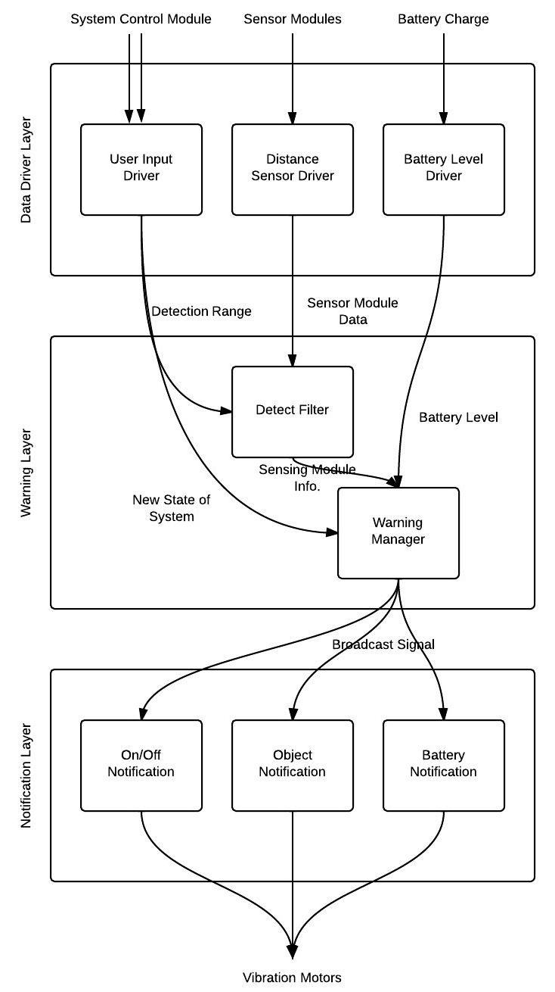
Figure 3-1: Architecture Layers Diagram

3.1 Data Driver Layer
This layer is in charge of taking in the input from the user, sensor modules, and the battery. The input signals will be converted into digital numeric values that can be manipulated by the microcontroller.

3.2 Warning Layer
This layer is in charge of processing all the input and output signals. Once the signals are received from the Acquisition and the Event Manager Layers, the logical unit processes each event and sends the signals to the Notification Layer.

3.3 Notification Layer
This layer is in charge of sending all the signals to the vibration motors in order to notify the user of each event. The events include the On/Off Notification, the Objected Detected Notification, and the Low Battery Notification.

4. Layer Description
This section will describe each of the layers defined in section 3 in more detail such as the functions, assumptions, and subsystems that comprise each layer.

4.1 Data Acquisition Layer
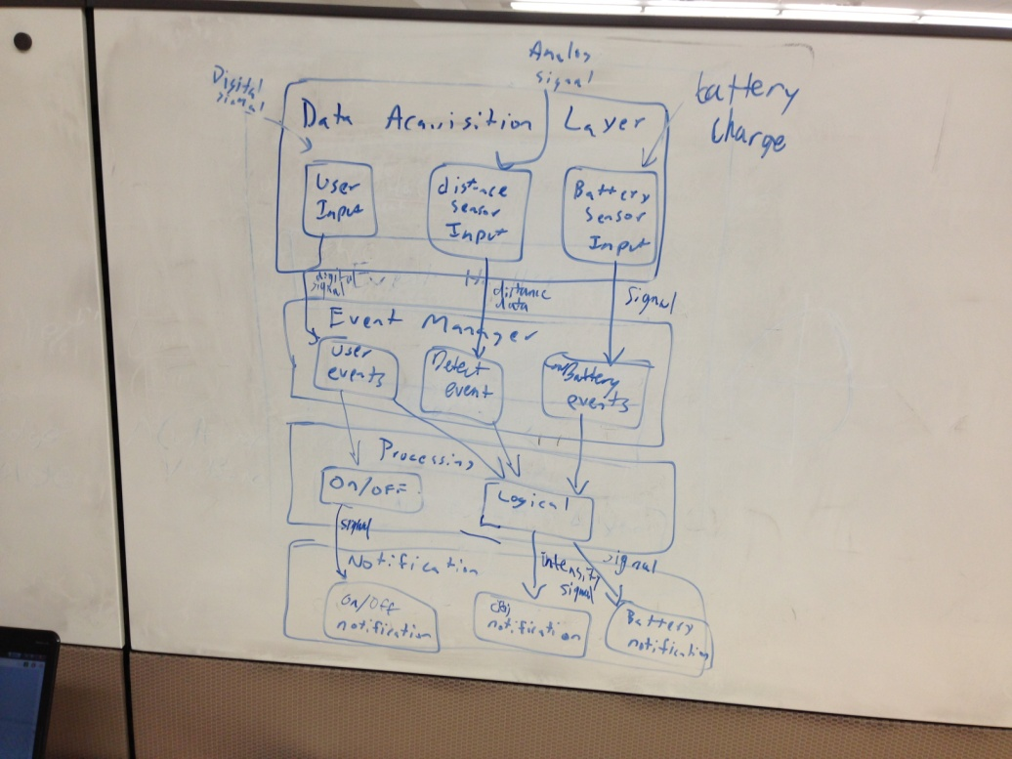
Figure 4-1: Data Acquistion Layer
4.1.1 Overview
The Data Acquisition Layer is where all initial data is gathered. Data from the user input such as the On/Off signal and the user selected detection range. Also, data from the sensors such as the distance of the detected object and finally the data containing the amount of power left in the battery.

4.1.2 Assumptions
- The system will only receive data from the user input, the distance sensors, and the battery.
- Any analog signal will be converted into digital.
- The data will be used in real time so no database to store the data will be necessary.
- The digital signal will be converted to binary for the purpose of processing it.

4.1.3 Responsibilities
This layer is responsible for taking in the input from the user, sensors, and the battery. The input signals will be converted into digital numeric values that can be manipulated by the microcontroller.

4.1.4 Subsystems
4.1.4.1 User Input
4.1.4.1.1 Description
User Input is a subsystem of the Data Acquisition Layer that has the same responsibilities as the layer that encompasses it, but focused on input from the user.
4.1.4.1.2 Assumptions
  - The user can only input data in the form of the On/Off Button, and the detection range knob.
  - Other form of input will not exist.
4.1.4.1.3 Responsibilities
This subsystem is only responsible for taking the digital signal from the On/Off button and the range knob and passing it to the Event Manager Layer.
4.1.4.1.4 Subsystem Inter-layer Interfaces
Method | Description | Information  Required | Information Returned
sendUserInput | Sends the User Input Data to the Event Manager layer | User Input Data | none
Table 4-1: User Input Inter-layer Interfaces
4.1.4.1.5 Subsystem Public Interfaces
Method | Description | Information  Required | Information Returned
readUserInput | Reads in any input from the user interacting with the system control module | none | User Input Data
Table 4-2: User Input Public Interface
4.1.4.2 Distance Sensor Input
4.1.4.2.1 Description
Distance Sensor Input is a subsystem of the Data Acquisition Layer that has the same responsibilities as the layer that encompasses it, but focused on input from the distance sensors.
4.1.4.2.2 Assumptions
  - The distance sensors will all work independently from each other.
  - The distance sensors will calculate the distance between the user and the object in feet.
  - The distance sensors will do the calculations in real time.
  - The distance sensors will function indoors and outdoors.
  - The distance sensors will function underneath clothes.
  - The distance sensors will use sound not light to determine distance.

4.1.4.2.3 Responsibilities
This subsystem is only responsible for taking the analog signal from the distance sensor and converting it to a digital signal and passing it to the Event Manager Layer.
4.1.4.2.4 Subsystem Inter-layer Interfaces
Method | Description | Information  Required | Information Returned
sendDistanceSensorInput | Sends the Distance Sensor Data to the Event Manager layer | Distance Sensor Input Data | none
Table 4-3: Distance Sensor Input Inter-layer Interfaces

4.1.4.2.5 Subsystem Public Interfaces
Method | Description | Information  Required | Information Returned
readDistanceSensorInput | Reads in any input from the distance sensors attached to the system | none | Distance Sensor Input Data
Table 4-4: Distance Sensor Input Public Interface
4.1.4.3 Battery Sensor Input
4.1.4.3.1 Description
Battery Sensor Input is a subsystem of the Data Acquisition Layer that has the same responsibilities as the layer that encompasses it, but focused on input from the battery sensor.
4.1.4.3.2 Assumptions
  - The Battery Sensor can calculate how much power is left in minutes.

4.1.4.3.3 Responsibilities
This subsystem is only responsible for taking the digital signal from the battery sensor and passing it to the Event Manager Layer.
4.1.4.3.4 Subsystem Inter-layer Interfaces
Method | Description | Information  Required | Information Returned
sendBatterySensorInput | Sends the Battery Sensor Data to the Event Manager layer | Battery Sensor Input Data | none
Table 4-5: Battery Sensor Input Inter-layer Interfaces
4.1.4.3.5 Subsystem Public Interfaces
Method | Description | Information  Required | Information Returned
readBatterySensorInput | Reads in any input from the battery sensor attached to the battery | none | Battery Sensor Input Data
Table 4-6: Battery Sensor Input Public Interface

4.2 Event Manager Layer
Figure 4-2: Event Manager Layer
4.2.1 Overview
The Event Manager Layer is to take in any input data acquired in the Data Acquisition Layer and determine what type of event has occurred, format the data, and forward it to the Processing Layer.

4.2.2 Assumptions
- Data sent from the Data Acquisition Layer is the only data that is to be handled (i.e. no other type of data will be handled)
- The data sent from the Data Acquisition Layer is to be in a format that can be analyzed to make decisions on the type of event that occurred.
- The data sent from the Data Acquisition Layer can be reformatted if necessary to allow the Processing Layer to fulfill its responsibilities.
- All features and functions must be performed in real-time

4.2.3 Responsibilities
The Event Manager Layer will be responsible for handling input data sent from the Data Acquisition Layer. The input data received by the Event Manager Layer represents a type of event. The Event Manager Layer will determine what type of event has occurred based on the input data received. Once a decision has been made, it will format the data in a form that is expected by the Processing Layer and forward the formatted data to that layer for processing.

4.2.4 Subsystems
4.2.4.1 User Event Manager
4.2.4.1.1 Description
The User Event Manager is a subsystem of the Event Manager Layer that has the same responsibilities as the layer that encompasses it, but focused on input data related to User Events.
4.2.4.1.2 Assumptions
  - Data sent from the User Input subsystem is the only data that is to be handled (i.e. no other type of data will be handled)
  - The data sent from the User Input subsystem is to be in a format that can be analyzed to make decisions on the type of event that occurred.
  - The data sent from the User Input subsystem can be reformatted if necessary to allow the subsystems of the Processing Layer (described later) to fulfill their responsibilities.
  - All features and functions must be performed in real-time

4.2.4.1.3 Responsibilities
The User Event Manager will be responsible for handling input data sent from the User Input subsystem of the Data Acquisition Layer. The input data received by the User Event Manager represents a type of User Event. The User Event Manager Layer will determine what type of User Event has occurred based on the input data received. Once a decision has been made, it will format the data in a form that is expected by the subsystems of the Processing Layer and forward the formatted data to those subsystems for processing.
4.2.4.1.4 Subsystem Inter-layer Interfaces
Method | Description | Information  Required | Information Returned
getUserInput | Reads in any User Input Data and returns the data read for determining type of User Event | none | User Input Data
sendOnOffData | Sends the formatted On/Off Data to the Processing Layer | formatted On/Off Data | none
sendDetectionRangeData | Sends the formatted Detection Range Data to the Processing Layer | formatted Detection Range Data | none
Table 4-7: User Event Manager Inter-layer Interfaces
4.2.4.1.5 Subsystem Public Interfaces
This subsystem does not interact directly with the external world.
4.2.4.2 Detection Event Manager
4.2.4.2.1 Description
The Detection Event Manager is a subsystem of the Event Manager Layer that has the same responsibilities as the layer that encompasses it, but focused on input data related to Object Detection Events.
4.2.4.2.2 Assumptions
  - Data sent from the Distance Sensor Input subsystem is the only data that is to be handled (i.e. no other type of data will be handled)
  - The data sent from the Distance Sensor Input subsystem is to be in a format that can be analyzed to make decisions on the type of event that occurred.
  - The data sent from the Distance Sensor Input subsystem can be reformatted if necessary to allow the Logical subsystem of the Processing Layer to fulfill its responsibilities.
  - All features and functions must be performed in real-time

4.2.4.2.3 Responsibilities
The Detection Event Manager will be responsible for handling input data sent from the Distance Sensor Input subsystem of the Data Acquisition Layer. The input data received by the Detection Event Manager represents a type of Object Detection Event. The Detection Event Manager will determine what type of Object Detection Event has occurred based on the input data received. Once a decision has been made, it will format the data in a form that is expected by the Logical subsystem of the Processing Layer and forward the formatted data to that subsystem for processing.

4.2.4.2.4 Subsystem Inter-layer Interfaces
Method | Description | Information  Required | Information Returned
getDistanceSensorInput | Reads in any Distance Sensor Input Data and returns the data read for determining type of Object Detection Event | none | Distance Data
sendDistanceData | Sends the formatted Distance Data to the Processing Layer | formatted Distance Data | none
Table 4-8: Detection Event Manager Inter-layer Interfaces
4.1.4.2.5 Subsystem Public Interfaces
This subsystem does not interact directly with the external world.
4.2.4.3 Low Battery Event Manager
4.2.4.3.1 Description
The Low Battery Event Manager is a subsystem of the Event Manager Layer that has the same responsibilities as the layer that encompasses it, but focused on input data related to Low Battery Events.
4.2.4.3.2 Assumptions
  - Data sent from the Battery Sensor Input subsystem is the only data that is to be handled (i.e. no other type of data will be handled)
  - The data sent from the Battery Sensor Input subsystem is to be in a format that can be analyzed to make decisions on the type of event that occurred.
  - The data sent from the Battery Sensor Input subsystem can be reformatted if necessary to allow the Logical subsystem of the Processing Layer to fulfill its responsibilities.
  - All features and functions must be performed in real-time

4.2.4.3.3 Responsibilities
The Low Battery Event Manager will be responsible for handling input data sent from the Battery Sensor Input subsystem of the Data Acquisition Layer. The input data received by the Low Battery Event Manager represents a type of Low Battery Event. The Low Battery Event Manager will determine what type of Low Battery Event has occurred based on the input data received. Once a decision has been made, it will format the data in a form that is expected by the Logical subsystem of the Processing Layer and forward the formatted data to that subsystem for processing.
4.2.4.3.4 Subsystem Inter-layer Interfaces
Method | Description | Information  Required | Information Returned
getBatterySensorInput | Reads in any Battery Sensor Input Data and returns the data read for determining type of Low Battery Event | none | Low Battery Data
sendLowBatteryData | Sends the formatted Low Battery Data to the Processing Layer | formatted Low Battery Data | none
Table 4-9: Low Battery Event Manager Inter-layer Interfaces
4.2.4.3.5 Subsystem Public Interfaces
This subsystem does not interact directly with the external world.

4.3 Processing Layer
Figure 4-3: Processing Layer
4.3.1 Overview
The Processing Layer is to take in any formatted data sent from the Event Manager Layer and make decisions based on the formatted data sent to send specific signals to the Notification Layer.

4.3.2 Assumptions
- Data sent from the Event Manager Layer is the only data that is to be handled (i.e. no other type of data will be handled)
- The data sent from the Event Manager Layer is to be in a format that can be analyzed to make decisions on the specific signal to send to the Notification Layer.
- All features and functions must be performed in real-time

4.3.3 Responsibilities
The Processing Layer will be responsible for making decisions on what type of signal to send to the Notification Layer based on the formatted data sent by the Event Manager Layer. The formatted data received by the Processing Layer will be processed to determine the specific signal needed to send to the Notification Layer. Once a decision has been made, it will send the signal determined to the Notification Layer in an expected format.

4.3.4 Subsystems
4.3.4.1 On/Off
4.3.4.1.1 Description
On/Off is a subsystem of the Processing Layer that has the same responsibilities as the layer that encompasses it, but focused on formatted data related to On/Off User Events.

4.3.4.1.2 Assumptions
  - Data sent from the User Event Manager subsystem is the only data that is to be handled (i.e. no other type of data will be handled)
  - The data sent from the User Event Manager subsystem is to be in a format that can be analyzed to make decisions on the type of signal to send to the On/Off Notification subsystem of the Notification Layer (described later).
  - All features and functions must be performed in real-time

4.3.4.1.3 Responsibilities
On/Off will be responsible for making decisions based on the formatted On/Off Data sent from the User Event Manager subsystem of the Event Manager Layer. The formatted On/Off Data sent by the User Event Manager will be processed to determine the type of signal to send to the On/Off Notification subsystem. Once a decision has been made, it will send the signal determined to the On/Off Notification subsystem.
4.3.4.1.4 Subsystem Inter-layer Interfaces
Method | Description | Information  Required | Information Returned
getOnOffInput | Reads in any On/Off Data and returns the data read for determining type of signal for On/Off event | none | On/Off Data
sendOnOffNotification | Sends the On/Off signal determined to the Notification Layer | On/Off signal | none
Table 4-10: On/Off Inter-layer Interfaces
4.3.4.1.5 Subsystem Public Interfaces
This subsystem does not interact directly with the external world.
4.3.4.2 Logical
4.3.4.2.1 Description
Logical is a subsystem of the Processing Layer that focuses on making decisions based on the formatted data sent by the subsystems of the Event Manager Layer.

4.3.4.2.2 Assumptions
  - Data sent from the Event Manager Layer subsystems are the only data that is to be handled (i.e. no other type of data will be handled)
  - The data sent from the Event Manager Layer subsystems are to be in a format that can be analyzed to make decisions on the type of signal to send to the Object Notification and Battery Notification subsystems of the Notification Layer (described later).
  - All features and functions must be performed in real-time

4.3.4.2.3 Responsibilities
Logical will be responsible for making decisions based on the formatted data sent from the Event Manager Layer subsystems. The formatted data sent by the Event Manager Layer subsystems will be processed to determine the types of signals to send to the Object Notification and Battery Notification subsystems. Once a decision has been made, it will send the signals to the Object Notification and Battery Notification subsystems.

4.3.4.2.4 Subsystem Inter-layer Interfaces
Method | Description | Information  Required | Information Returned
getUserData | Reads in any formatted data from the User Event Manager subsystem and returns the data read for determining type of signal to send to the Object Notification subsystem?????? | none | formatted User Event Data
getDistanceData | Reads in any formatted data from the Detection Event Manager subsystem and returns the data read for determining type of signal to send to the Object Notification subsystem | none | formatted Distance Data
getLowBatteryData | Reads in any formatted data from the Low Battery Event Manager subsystem and returns the data read for determining type of signal to send to the Low Battery Notification subsystem | none | formatted Low Battery Data
sendIntensitySignal | Sends an Vibration Intensity Signal to the Object Notification subsystem | Vibration Intensity Signal | none
sendLowBatterySignal | Sends a Low Battery Signal to the Low Battery Notification subsystem | Low Battery Signal | none
Table 4-11: Logical Inter-layer Interfaces
4.3.4.2.5 Subsystem Public Interfaces
This subsystem does not interact directly with the external world.

4.4 Notification Layer
Figure 4-4: Notification Layer
4.4.1 Overview
The Notification Layer is to take in any signals sent from the Processing Layer and, based on the signal received, notify the user through vibration patterns what event (System On/Off, Object detected, Low Battery) has occurred.

4.4.2 Assumptions
- Signals sent from the Processing Layer are the only data that is to be handled (i.e. no other type of data will be handled)
- The signals sent from the Event Manager Layer are to be in a format that can be analyzed to make decisions on the specific vibration pattern to send to notify the user.
- The vibration motors will be able to operate with different vibration patterns
- All features and functions must be performed in real-time

4.4.3 Responsibilities
The Notification Layer will be responsible for making decisions on what type of vibration pattern to send to use to notify the user. The signals received by the Processing Layer will be processed to determine the specific vibration pattern to use to notify the user. Once a decision has been made, it will notify the user with the vibration pattern selected

4.4.4 Subsystems
4.4.4.1 On/Off Notification
4.4.4.1.1 Description
The On/Off Notification Subsystem will receive commands from the On/Off Subsystem and interpret them into appropriate sensor module instructions
4.4.4.1.2 Assumptions
- The On/Off Notification Subsystem will support control of eight sensor modules

4.4.4.1.3 Responsibilities
The On/Off Notification Subsystem will be responsible for interpreting the On/Off Subsystem’s instructions and for delivering voltage to the sensor modules
4.4.4.1.4 Subsystem Inter-layer Interfaces
Method | Description | Information  Required | Information Returned
notificationListener | The On/Off Subsystem will listen for instructions from On/Off Subsystem | None | Request
Table 4-12: On/Off Notification Inter-layer Interfaces
4.4.4.1.5 Subsystem Public Interfaces
Method | Description | Information  Required | Information Returned
systemOnOff | Notify the user that the system is On/Off with vibrations | None | Request
Table 4-13: On/Off Notification Public Interface
4.4.4.2 Object Notification
4.4.4.2.1 Description
The Object Notification Subsystem will receive commands from the Logical Subsystem and interpret them into appropriate sensor module instructions
4.4.4.2.2 Assumptions
- The Object Notification Subsystem will support control of eight sensor modules

4.4.4.2.3 Responsibilities
The Object Notification Subsystem will be responsible for interpreting the Logical Subsystem’s instructions and for delivering voltage and instructions to the sensor modules

4.4.4.2.4 Subsystem Inter-layer Interfaces
Method | Description | Information  Required | Information Returned
notificationListener | The Object Subsystem will listen for instructions from the Logical Subsystem | None | Request
Table 4-14 Object Notification Inter-layer Interfaces
4.4.4.2.5 Subsystem Public Interfaces
Method | Description | Information  Required | Information Returned
objectNotification | Notify the user that there is an object nearby with vibrations | None | Request
Table 4-15: Object Notification Public Interface
4.4.4.3 Battery Notification
4.4.4.3.1 Description
The Battery Notification Subsystem will receive commands from the Logical Subsystem and interpret them into appropriate sensor module instructions
4.4.4.3.2 Assumptions
- The Battery Notification Subsystem will support control of eight sensor modules

4.4.4.3.3 Responsibilities
The Battery Notification Subsystem will be responsible for interpreting the Logical Subsystem’s instructions and for delivering voltage and instructions to the sensor modules

4.4.4.3.4 Subsystem Inter-layer Interfaces
Method | Description | Information  Required | Information Returned
notificationListener | The Notification Subsystem will listen for instructions from the Logical Subsystem | None | Request
Table 4-16: Battery Notification Inter-layer Interfaces
4.4.4.3.5 Subsystem Public Interfaces
Method | Description | Information  Required | Information Returned
batteryNotification | Notify the user that there the system’s battery is low | None | Request
Table 4-17: Battery Notification Public Interface

5. Inter-Subsystem Data Flow

Inter-Subsystem Data Flow Section
This section details the data flow between each subsytem in the layered architecture of the Sight By Touch system.
1
2
3
4
5
6
7
8
9
10
11
12
13
Figure 5-1. Architectural Data flow Diagram.

The following table will describe the data flows between subsystems in tabular form.
Table 5-1. Sample Inter-Subsystem Data Element Descriptions.
Data Element |  | Descriptions
1. Input from user | The data from the system control module regarding user input as a digital signal
2. Input from the distance sensors | The data from the distance sensors regarding object detection as an analog signal
3. Input from battery sensor | The data from the battery sensor regarding the charge of the battery as an analog signal
4. User Input signal | The digital signal sent by the User Input subsystem to the User Event Manager subsystem to determine type of User Event
5. Distance Data | The distance information derived by the Distance Sensor Input subsystem to determine the type of Object Detection Event
6. Low Battery Signal | The signal sent by the Battery Sensor Input subsystem that will determine the type of Low Battery Event
7. On/Off Signal | The digital signal sent by User Event subsystem to the On/Off subsystem to process the type of notification to send to the On/Off Notification subsystem
8. Range Data | Data that will be used by the Logical subsystem to determine whether the Object detected is within the range specified by the user in order to decide to notify the user or not
9. Object Detection Data | Data that will be used by the Logical subsystem to process the type of notification to send to the Object Notification subsystem
10. Low Battery Data | Data that will be used by the Logical subsystem to process the type of notification to send to the Low Battery Notification subsystem
11. On/Off Notification Signal | The signal that will be sent to the On/Off Notification subsystem to tell the subsystem exactly what notification to use to notify the user that the system has been turned on/off
12. Intensity Signal | The signal that will be sent to the Object Notification subsystem to tell the subsystem exactly what notification to use to notify the user that the system has detected an object at a particular range
13. Low Battery Signal | The signal that will be sent to the Low Battery Notification subsystem to tell the subsystem exactly what notification to use to notify the user how much charge the battery has left to power the system

The following table documents the actual data flow paths of the data elements between subsystems in the form of a Producer-Consumer matrix.
Table 5-2. Producer-Consumer Relationships.
 | Consumer Subsystem
Producer  Subsystem | User Event Manager | Detection Event Manager | Low Battery Event Manager | On/Off | Logical | On/Off Notification | Object Notification | Low Battery Notification
User Input | 4.
Distance Sensor Input |  | 5.
Battery Sensor Input |  |  | 6.
User Event Manager |  |  |  | 7. | 8.
Detection Event Manager |  |  |  |  | 9.
Low Battery Event Manager |  |  |  |  | 10.
On/Off |  |  |  |  |  | 11.
Logical |  |  |  |  |  |  | 12. | 13.

6. Operating System Dependencies

6.1 Data Acquisition Layer
The Data Acquisition Layer is dependent on the type of user interface, distance sensors, and battery measuring mechanism used.

6.2 Event Manager Layer
The Event Manager Layer will be developed in the C programming language on a microcontroller. It will be dependent on the type of microcontroller and associated libraries used.

6.3 Processing Layer
The Processing Layer will be developed in the C programming language on a microcontroller. It will be dependent on the type of microcontroller and associated libraries used.

6.4 Notification Layer
The Notification Layer will be dependent on the types of vibration motors used to notify the user.

7. Testing Considerations
In this section, we will define testing considerations relevant to each layer of the architecture that are addressed in this section. This is not a full testing plan, but ideas and goals that address how we will verify and validate the architecture that we have specified.
This section is divided into two subsections. We define the considerations on how to approach the validation of our system overall and at each layer in the architecture.

7.1 Overall Considerations

Durability
- Wearing: The user shall be able to easily wear the System. Once worn, the System should stay on the user comfortably.
- Toughness: The System shall be able to withstand any normal day-to-day contact the user would normally experience during operation.

User
- Ease of Use: All layers should be designed and tested as to have minimal work for the user. The user should only be responsible for wearing the System, attaching connections to the System Control Unit, and communicating information from the user input in the Data Acquisition Layer. Any other functions required for the Sight By Touch System shall be handled by the System itself.
- Clarity: The Data Acquisition Layer and Notification subsystems shall clearly communicate to the user.

Layer-level Considerations

Data Acquisition Layer
- Minimal Integration: Any User input, Sensor input and Battery charge input should communicate individually to its event subsystem inside the Event Handler Layer.
- Independence: Any sensors within the Data Acquisition Layer shall be independent of each other, and should work and supply information in the case that any of the other sensors fail. The Data Acquisition Layer’s performance shall be independent of the other layers.
- Data Integrity: Data retrieved from the User, Sensors and Battery charger shall be retrieved in a timely manner so that the System Control Unit can produce real time feedback.

Event Manager Layer
- Communication: The Event Handler Layer must be able to gather and transmit appropriate information to the Processing Layer. This information must be preprocessed and prepared before being sent to the Powering/Logical subsystems.
- Independence: The Event Handler Layer must not be dependent on any other layers. The Event Handler Layer shall be designed so that if any other event is created, no other components of the architecture shall need to be altered. The Event Handler Layer shall only communicate with the Processing Layer.

Processing Layer
- Centralized Control: All controls and decisions will be made in the Processing Layer. All communication with the Event Handler Layer is for the purposes of retrieving and/or sending information.
- Independence: The Processing Layer shall be designed in a way that if a new Processing Layer was composed, no other layers shall need to be altered. Black Box Testing shall be utilized for all subsystems within the Processing Layer.

Notification Layer
- Correctness: The Notification Layer shall be designed with proper code to clearly differentiate between object, on and off notifications.
- Fault Notification: The Processing Layer shall be able to detect if there is a simple malfunction in the Notification Layer.

